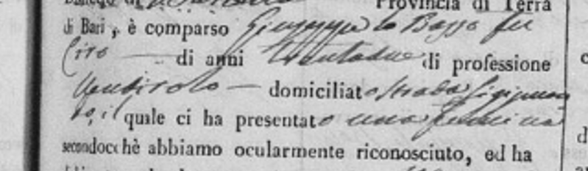
Filomena Lobasso Dad Occupation

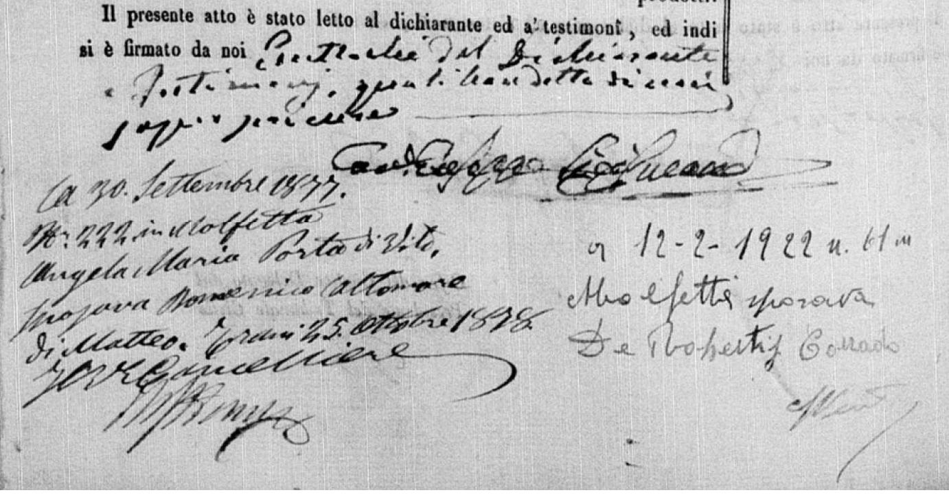
What this whole thing says. I believe says she married Domenico Altomare in 1877 but what does the bottom part say. Also what does the section with Corrado De Robertis say 1922? She would have been 80 if that means married again?

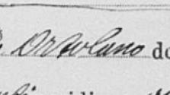
Maria Magarelli Dad Profession

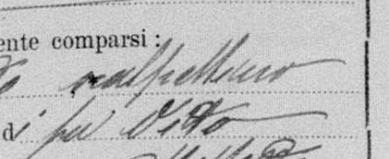
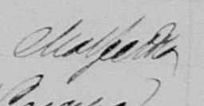
Giovanni Porta 1880 profession

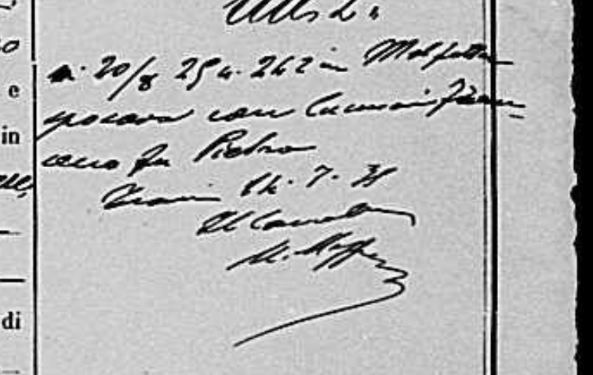
Angela Marie 2nd Partner 1891

