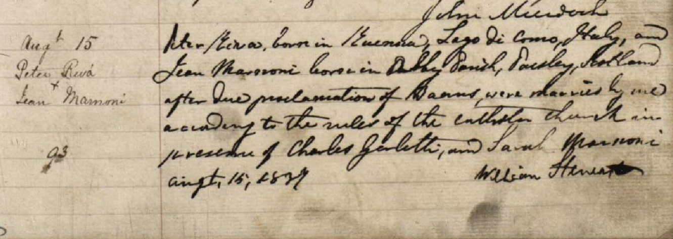
1837. Riva, Peter – Marnoni, Jean (S.C.A. Marriages MP 62 1 4 2 113-, Glasgow, St Andrews) * SCA = Scottish Catholic Archives.

